KIDS AT HEART TOYS—CELEBRATING 30 YEARS ON HAWTHORNE

By Jack Rubinger
October 2, 2017

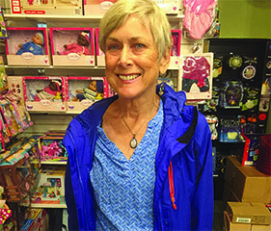
Elizabeth Campbell from Kids at Heart Toys is celebrating her store’s 30th year on Hawthorne Blvd.

“Thirty years on Hawthorne sure went fast,” she said. “My son was three months old when we began and now he’s 30.”

Campbell now has customers that shopped at the store as children bringing their own kids to Kids at Heart and has hired former kid customers in the past and present.
She has always given to her community through volunteering at schools, teaching English at SE Works and through Kids at Heart Toys. The store is known as a happy, safe space where parents can come together to share experiences and learn from each other.

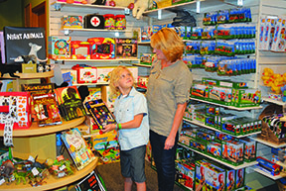
Campbell, like many Hawthorne Blvd. veterans, has seen stores come and go. She’s witnessed the famed Hawthorne Renaissance which took place in the 70s and 80s and attributes tenacity and good budgeting to her longevity. She’s evolved from selling used items and having more than one store.

While she believes kids haven’t really changed over the years, she does see a downside to the amount of screen time kids and their families rely on more and more these days because there’s less human interaction.

“I strongly believe that children learn through play. Toys that cultivate mind, body and spirit give the next generation an inestimable head start,” she said.
Fortunately, classic board games and puzzles are still popular as well as items like Crazy Aaron’s Thinking Putty, sort of like silly putty but more fun, and requiring more creativity to manipulate and made in the US by people with disabilities.
Her team values people over money, and they strive every day to put the “heart” in Kids at Heart. Every year, her store donates money and toys to organizations on a local, national and international level. She has always believed in supporting the community that supports her.

Sharing all those puzzles, building blocks and stuffed animals with kids, parents and grandparents over the years has brought her great joy though this year is bittersweet for Campbell as she is suffering from end stage kidney disease and is now on home dialysis.

She needs a kidney transplant so she can live a long and normal life. Being on dialysis is very difficult and limits what she can do. She is on the transplant list at OHSU but that can take an average of 3 and 1/2 years or longer.

The better option would be if she had a living kidney donor. Living donor kidneys usually last twice as long. She is reaching out to her community now for help.
“I am looking for a kidney hero,” she said.

Campbell believes there are altruistic donors out there and has been absorbing news stories about people donating their kidney. She’s personally met someone who donated her kidney to a total stranger.

Typically a shy and modest person, she has come out of her shell to let people know what’s happening and has created a Facebook page called A Kidney for Elizabeth.
Elizabeth has been busy attending support groups and talking to friends, family and customers, but she’s reluctant to go too far away for fear that she might potentially miss getting a transplant.

Meanwhile, she waits, smiles a lot and talks up a storm. For more information about being a living kidney donor, visit facebook.com/kidneyforelizabeth or email Elizabeth Campbell directly through elizabeth@kidsathearttoys.com.

Reference: https://www.southeastexaminer.com/2017/10/kids-at-heart-toys-celebrating-30-years-on-hawthorne/

