Paired Kidney Exchange &
Kidney Transplant Chains

“I have a living donor who isn’t a match, what can I do?”

What is Paired Kidney Exchange?

Paired kidney exchange, also called kidney paired donation, involves two (or more) living donors swapping recipients to make compatible matches. Paired exchange takes place when an approved donor is not a good medical match for their intended recipient but is still willing to donate. In such cases, another incompatible donor-recipient pair is located and the living donor kidneys are swapped, offering compatible transplants to both patients.

United Network for Organ Sharing (UNOS) provides this example: Mary wants to donate a kidney to Carlos, but they do not match. Amir wants to donate to Shauna, but they do not match. However, Mary is a match for Shauna, and Amir matches Carlos. Switching donors and recipients in this case allows both transplants to happen.
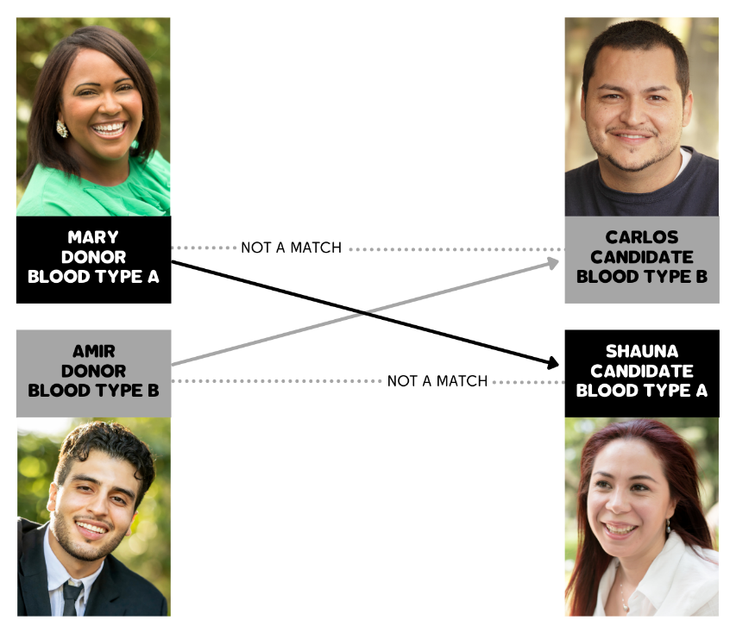

These exchanges can also work for patients who have blood type-compatible donors, but are sensitized against their donor's tissue.

Why is Understanding Paired Exchange Important?

It can be challenging for patients in need of a kidney transplant to find compatible donors. The paired exchange option increases the donor pool by eliminating the need for donors and recipients to be a blood type match.

According to the UCLA Kidney Exchange Program, “Approximately one-third of patients who have a willing living kidney donor will not be able to receive the donor kidney because of an incompatible blood type or incompatible crossmatch.” In the past, the only option for these individuals was to search for a different living donor or continue waiting for a deceased donor kidney to become available. Paired exchange enables the transplant to move forward.

University of Minnesota Health Transplant Surgeon Dr. Ty Dunn elaborates, “The paired exchange program increases the possibility that a person can find a match for a living donor kidney transplant [which] offers the best long-term outcome for patients and gives them the chance to get off dialysis sooner.”

How Does the Paired Exchange Process Work?

There are multiple national programs that coordinate with transplant centers to facilitate matching for paired exchanges through the use of computer algorithms. Your transplant center will provide you information about the specific program(s) they work with and get you enrolled. Typically patients enrolled in paired exchange programs remain active on the deceased donor waitlist. Once a paired exchange match is made, in almost all cases, donor and recipient surgical procedures take place at their respective home transplant centers. No patient travel is required, as kidneys can be safely transported.

What is a Kidney Donor Chain? How Does It Relate to Paired Exchange?

A kidney donor chain begins with a non-directed donor—an individual who decides to donate out without a specified recipient. This donated kidney is transplanted into a recipient who had a donor willing to give a kidney, but was not a compatible match. To keep the chain going, that patient’s incompatible donor gives a kidney to a patient unknown to them who has been identified as a match, essentially "paying it forward.”

Chains can continue as long as matches are found. An amazing example is the University of Alabama at Birmingham’s ongoing kidney donation chain which began in 2013 and has provided 114 patients with kidney transplants so far.

A kidney donor chain creates opportunities for a large number of recipient-donor pairings. They use a specialized computer program to match donors and recipients across the country. The Mayo Clinic elaborates, “A donation chain as part of kidney paired donation finds the best kidney for every patient. Being part of an organ chain through kidney paired donation is a great alternative to receiving a living donor kidney transplant from your directed living donor if the two of you are not a match.”


References

Mayo Clinic. Infographic: Paired Donation Chain. https://www.mayoclinic.org/tests-procedures/living-donor-kidney-transplant/multimedia/paired-donation-chain-infographic/ifg-20469331

Michigan Medicine at University of Michigan. Living Kidney Donation: Kidney Paired Donation.
http://www.med.umich.edu/pdf/adult/KidneyBooklet.pdf

Stanford Health Care. Kidney Transplant—Paired Kidney Donation.
https://stanfordhealthcare.org/medical-treatments/k/kidney-transplant-surgery/types/paired-kidney-donation.html

University of Alabama at Birmingham. Celebrating the Nation’s Longest Kidney Chain.
https://www.uab.edu/kidneychain/

University of California - Los Angeles Kidney Exchange Program. What is Kidney Exchange? https://www.uclahealth.org/transplants/kidney-exchange/about-us

University of California - Los Angeles Kidney Exchange Program. What is a Kidney Chain?
https://www.uclahealth.org/transplants/kidney-exchange/kidneychain

University of Minnesota Medical Center. What is a Paired Kidney Exchange?
https://www.mhealth.org/blog/2017/march-2017/what-is-a-paired-kidney-exchange

United Network for Organ Sharing. Kidney Paired Donation. https://unos.org/transplant/kidney-paired-donation/

United Network for Organ Sharing. OPTN Kidney Paired Donation Pilot Project.
https://unos.org/wp-content/uploads/unos/Brochure-108-Kidney-paired-donation.pdf

