Transtheoretical Model of Behavioral Change (TTM)
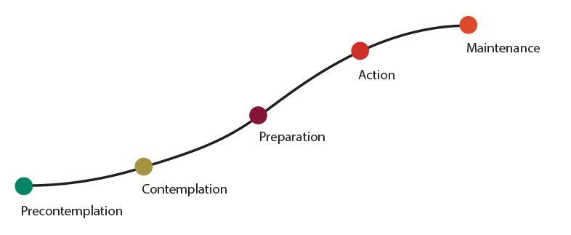

STAGES OVERVIEW

During the precontemplation stage, people are not yet considering a change. Identifying behaviors: denial, unawareness that change is needed, feeling resigned to the current state of things.

During the contemplation stage, people become increasingly aware of the potential benefits of making a change, but the costs tend to stand out even more. This is stage is a common stuck-point in the change process. Identifying behaviors: ambivalence, conflicted emotions.

During the preparation stage, people begin making small changes to prepare for a larger life change. At this stage they may begin gathering resources, creating goals, and seeking out support. Identifying behaviors: experimenting with micro-changes, collecting information.

During the action stage, people begin taking direct action in order to accomplish change and move toward their goals. At this point, positive reinforcement and support are extremely important in helping maintain progress toward change. Identifying behaviors: making a commitment, taking definitive steps.

During the maintenance stage, people successfully keep up new behaviors and make further progress toward their goal. In this stage, folks become more assured that they will be able to continue their change. Identifying behaviors: maintenance of change-related behaviors, continued engagement in positive actions, optimism.

WHERE IS YOUR MENTEE AT?

Be prepared to meet your mentee at whichever stage they are in and support their transition into the next one. Don’t expect them to be ready for something that they are not. Pushing will result in frustration on both sides.

WHERE IS YOUR MENTEE COMING FROM?

Navigating kidney failure is an emotional rollercoaster. When encouraging positive changes in your mentee, it is important to consider how their emotional state may impact their willingness and/or ability to change. Common emotional experiences include:

- Loneliness; isolation | - Hopelessness; depression
- Feeling discouraged | - Anger; resentment

PRECONTEMPLATION
MAINTENANCE
ACTION
PREPARATION
CONTEMPLATION

