*Please rate yourself in the following areas by circling the number that feels most true to you. After you rate yourself, reflect with your partner on why you chose that number and what support you need to move to a higher number.

Knowledge
How knowledgeable am I about living kidney donation?
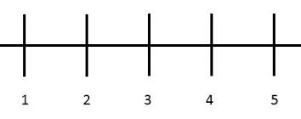
Self-Care
How important is it for me to focus on my own self-care?
Readiness
How ready am I to seek a living donor?
Importance
How important is it for me to seek a living donor now?
Confidence
How confident am I that I can be effective in finding a living donor?

