Living Kidney Donation Educational Resources

 | Donate Life Northwest | Erase the Wait  www.donatelifenw.org/erasethewait  Marissa Markintire | Manager of Education Initiatives  503.494.2257 | markma@ohsu.edu
      . | Transplant Centers  Please look up specific contact info for your care team  Legacy Transplant Services: (503) 413-6555  OHSU Clinical Transplant Services: (503) 494-8500  Veterans Affairs Portland Transplant Services: (503) 721-7860
 | United Network for Organ Sharing (UNOS)  www.unos.org  - General resource to learn more about donation, transplant, and how organs are allocated.  - Information on paired exchange donation: www.unos.org/donation/kidney-paired-donation  - Detailed information and facts about organ transplants: www.transplantliving.org  - “How the National Organ Transplant Waiting List Works” informational video: www.youtube.com/watch?v=f4bW9exS6vY&feature=youtu.be (OR search video title on YouTube)
 | American Society of Transplantation Live Donor Toolkit (AST)  www.livedonortoolkit.com  - This toolkit was designed to add to the general information about living donation that you can find on the Transplant Living website or may have received from your transplant center. The kits were designed for people considering living donation, and their loved ones.
 | National Living Donor Assistance Center  www.livingdonorassistance.org  - Provides reimbursement of travel and related expenses to people being evaluated for and/or undergoing living organ donation. Priority is given to those who could not otherwise afford to donate.

 | National Kidney Registry  www.kidneyregistry.org  - Help with finding pairs/compatible matches.  - Helps to find most compatible matches possible (through pairing swaps) throughout nation.
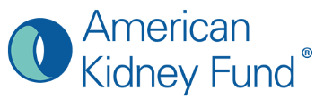 | American Kidney Fund (AKF)  www.kidneyfund.org  - Nonprofit focused on helping people fight kidney disease through providing programs and services such as prevention activities, health education resources, and direct financial assistance.
 | National Kidney Foundation  www.kidney.org  Information on kidney disease and organ donation and transplant.
 | Infórmate –  www.informate.org  - Bilingual site designed for Latinos by the Health Resources and Services Administration.  - Great information for all ethnicities on living kidney donation.  - Special focus on cultural resources for Latinos in the US.
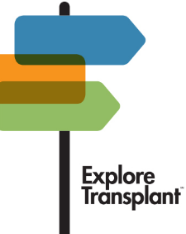 | Explore Transplant  www.exploretransplant.org  - Information on living donation.  - To view the Explore Transplant videos online, please visit: www.exploretransplant.org/et-eld-education-videos  - Username: ETELDErasetheWait  - Password: ETELD2019!
 | American Association of Kidney Patients (AAKP)  www.aakp.org  - Association dedicated to improving the quality of life for kidney patients through education, advocacy, patient engagement, and fostering patient communities.
 | Living Kidney Donor Network  www.lkdn.org  - Education and resources for finding a living donor, including workshops, conference calls, and webinars.

