

Corvallis woman seeks kidney donor—even from a Ducks fan

Alex Paul | Sep 21, 2020 | Updated Oct 6, 2020
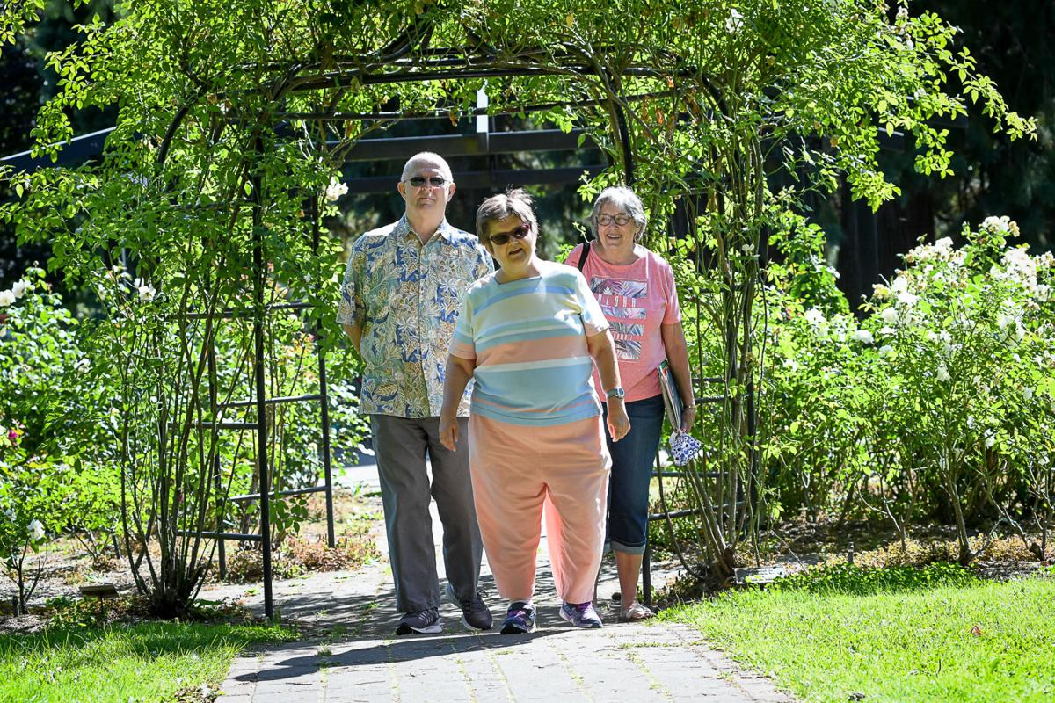
Corvallis resident Leslie Olsen is a diehard OSU Beavers sports fan, but she would gladly accept a kidney from a University of Oregon Ducks fan.

And she would be ecstatic if Donny Osmond stepped up to the plate — he is her all-time favorite entertainer. She’s been to three of his concerts.

Olsen’s kidney is functioning at only 8% of normal, but so far, she has not had to rely on dialysis to maintain her daily lifestyle.

Olsen, 48, is used to medical procedures. Doctors believe she suffered a stroke inutero — while still in the womb — which led to developmental disabilities and other medical issues.

“I’m a human pin cushion,” Olsen jokes about how many times she has had blood drawn for testing.

The daughter of Tony and Sandi Olsen lives on her own with assistance and works part-time for the Benton County Developmental Diversity Program and Oregon State Credit Union.

Her kidney issue was diagnosed about 6 years ago and she has been on the kidney transplant list since April 2019.

There are several ways Olsen can receive a kidney, according to her mother.

“Her best chance of receiving a kidney is from a living donor,” Sandi Olsen said. “Her father and I have both been screened and don’t qualify for various issues.”

Olsen said the waiting time to receive a kidney from a deceased donor is three to five years, possibly up to eight years.

“She has several things in her favor including she is relatively young, is in general good health and is not on dialysis,” Olsen said.

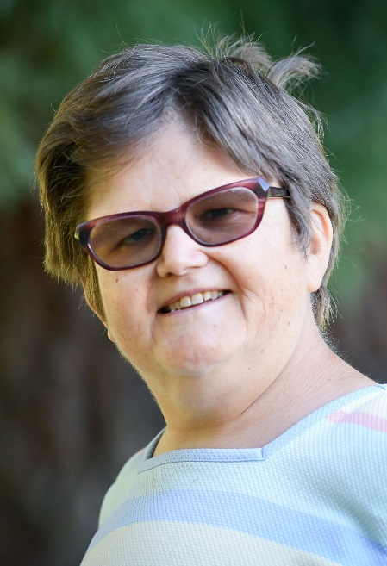
Olsen said donations can also be matched by “chain” of individuals donating to others until a matching donor is found for Leslie.

The Olsens are working through Legacy Good Samaritan Medical Center in Portland. Transplants are also done at OHSU.

Potential donors can go online to learn more about the process, but it starts with some blood tests and a medical screening.

“A donor does not have to be living here,” Sandi Olsen said. “Most people have two kidneys and we only need one. Share the spare is our new motto.”

Olsen said a donor will spend about two days in a hospital and fully recover within a month.

They bear no expense for the procedure and they could be reimbursed for their time off work as well as travel expenses.

Once Leslie went on the transplant list, they sent out more than 300 emails to family and friends.

According to information provided by Legacy Health, transplant patients live twice as long as those who stay on dialysis and more than 97% of transplant patients are alive one year after surgery and 93% after three years.

There are almost 700 patients waiting for a kidney in Oregon and almost 95,000 waiting nationwide. Every 10 minutes another person is added to the waiting list.

Almost 50% of patients who received a deceased donor transplant at Legacy Health in the last year had to wait more than five years.

While she waits, Olsen will continue to watch NFL football, rooting for her Denver Broncos and Pittsburgh Steelers.

“I’m OK with all of this, but I’m a little overwhelmed,” Leslie said.

To learn more, call 503-413-6555 or visit http://legacy.donorscreen.org.

A website has been established through the National Kidney Registry. Leslie and her family ask you to post and share her link: www.nkr.org/RCW285.

