Anger Management Relaxation Techniques
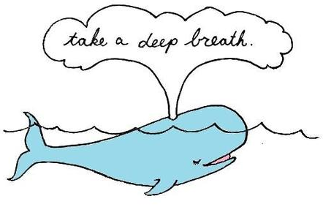

The following discussion describes common anger management techniques. These techniques will not produce results if you use them only casually. You must be committed to routinely using and practicing these techniques in order for them to positively affect your life.

Overview: Controlled Deep Breathing and Muscle Relaxation

- Your breathing rate and heart rate both increase when you become emotionally aroused. You can learn to reverse these increases by deliberately slowing your breathing and/or systematically relaxing your tense muscles. Relaxing in this manner will help you to maintain control.

- You may find yourself breathing quick, shallow breaths when you are upset. Allowing this shallow chest-only breathing to continue will only exacerbate your anger. Instead, take action to redirect your breathing and relax your muscles so that you will calm down. Set aside at least 15 minutes (ideally 20-30 minutes) in which to engage in relaxation exercises. Less than 15 minutes will not likely be beneficial!

Instructions: Slow Breathing

- Start your relaxation efforts by taking several slow and deep breaths in a row, each time taking care to exhale for twice as long as you inhale.

- Count slowly to four as you breathe in, and then breathe out slowly as you count to eight.

- As you do this, notice where the air in your lungs is going. Open your lungs and breath deeply across the lung's full range.

- Your breath should enter your belly first, then your chest, and finally your upper chest just below your shoulders.

- Feel your ribs expand as your lungs expand.

- Pay attention to how your ribs return to their original location as you exhale completely.

Continue this breathing pattern for several minutes, returning immediately to normal breathing if at any time you feel odd or out of breath. Slow, deliberate and controlled deep breathing in this manner will help return your breath to a more normal, relaxed pattern. Because all things in the body are connected to each other, it is very likely that as you control your breath, you will also cause your heart rate to slow down, and some of your muscular tension to abate too.

Instructions: Progressive Muscle Relaxation

Anger frequently manifests in the form of muscle tension. This tension can collect in your neck and shoulders which may remain tense long after your anger is gone. If your neck is tense, slowly and gently (and we mean GENTLY) roll your head toward one shoulder and then towards the other. Coordinate your head role with your breathing. Roll your head gently to one side as you exhale, back to the center as you inhale and to the other side as you exhale again. Carefully repeat this technique several times until you feel the muscles in your neck relax a little.

You can work out some of your shoulder tension by deliberately and carefully shrugging your shoulders and releasing them several times. Shoulder rolls backward and forward can also help. Using these techniques together will help you to relax. As your face, neck, and shoulders become more relaxed, see if you can identify tension in other parts of your body.

If relaxation techniques alone don't work, try the opposite:

- Tighten and tense the stressed muscles for a slow count of ten and then release them. Be sure to release your tightened muscles immediately if you feel any pain!

- Move from one muscle group to the next until you have treated each section of your body to a cycle of tension and release.

- With a little practice, you can work your way down your entire body in a few minutes. Tensing and then relaxing your muscles can sometimes help you to achieve a better quality relaxation.

Conclusion

In all you should give yourself 20 to 30 minutes to calm down. Keep your breathing very deep and very regular during this time. Remind yourself that you are calming yourself down and soon you will be feeling much calmer.

Relaxation techniques such as those described just above can help you to relax and decrease anger. They also give you time to think about the situation that has upset you; time that may help you generate fresh solutions or view things from alternative perspectives.

Reference:

MentalHelp.net, “Anger Management Relaxation Techniques”
https://www.mentalhelp.net/anger/management/relaxation-techniques/

