CIRCLES OF SUPPORT

OVERVIEW

Your circles of support are representative of the people that can help you navigate this challenging time in your life and assist you in spreading the word about your need for a kidney donor. It is essential to cultivate and engage with a strong support system. You will need support as you move through the steps of sharing your story, seeking a living donor, and navigating the transplant process. There are four basic relationship “circles” to consider:

The Circle of Intimacy is made up of people you love, feel safe with, and are able to be vulnerable with. This circle usually includes family members and very close friends.

The Circle of Friendship consists of people you may call to chat with, grab coffee with, see a movie with, or join in a shared interest with. These are people you consider good friends.

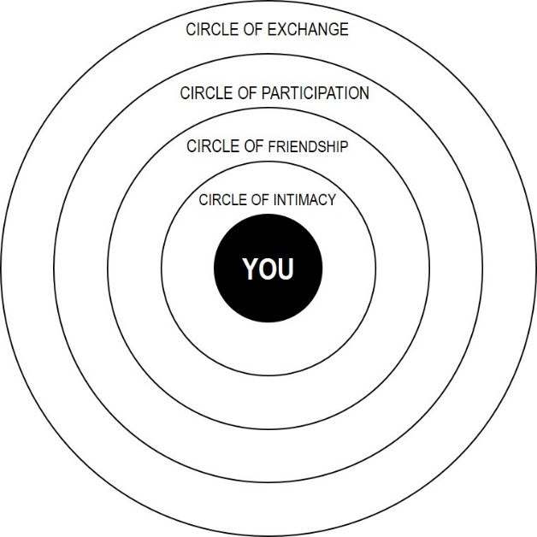
The Circle of Participation is comprised of people from the various spheres in which you participate, including colleagues at work or school, members of a sporting group, or fellow volunteers at church. These people are typically considered acquaintances.

The Circle of Exchange includes people who are paid to be in your life. Examples include doctors, teachers, social workers, hairstylists, etc. These relationships are purely transactional.

For simplicity’s sake, you can also think of it this way:

Circle of Intimacy + Circle of Friendship = Inner Circle
Circle of Participation + Circle of Exchange = Outer Circle

INSTRUCTIONS

Use the worksheet on the next page to brainstorm and identify people within your various circles. Then fill in the blank circles on the last page to create a visual representation of your own circles of support.

- Try to think of as many individuals and groups as you can; ask family and friends to help. In addition to “real world” relationships, be sure to include virtual connections as well.

- Keep in mind, even if someone cannot be a donor, there are many other ways they can help.

- It can be useful to reflect on past life challenges and think about the people who provided support, resources, encouragement, etc.

- Think about not only your personal connections, but also those of other family members and friends (e.g., your neighbor’s daughter works for a newspaper, your cousin’s husband does website design, your best friend’s step-daughter is a social media wiz).
CIRCLES OF SUPPORT BRAINSTORM
Who might consider donating, help share your story, or provide support in other ways?

CLOSE FAMILY | FRIENDS
DISTANT RELATIVES | NEIGHBORS & ACQUAINTANCES
COWORKERS & PROFESSIONAL NETWORK | SCHOOL & ALUMNI GROUPS
SORORITY OR FRATERNITY | MILITARY CONNECTIONS
RELIGIOUS OR SPIRITUAL GROUPS | RECREATIONAL GROUPS OR SPORTS TEAMS
COMMUNITY GROUPS | VOLUNTEER OR CHARITY GROUPS
CLUBS & CIVIC GROUPS | HOBBY GROUPS
OTHER
MY CIRCLES OF SUPPORT
ME

