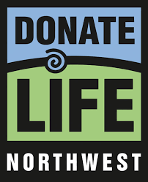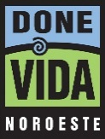

Sharing the Gift of Life: A Resource Guide for Faith Leaders

Raising the subject of organ and tissue donation is important at any time during the year. Donate Life Northwest is the non-profit educational agency serving Oregon and Southwest Washington by providing support and materials regarding donation.

Here are a few of the ways we can help:
- Organize donor drives, We can help your faith community organize a donor drive that makes it easy for members and others to learn the facts, sign up to become donors, and share their decision with their families.
- Arrange workshops, we can provide information or set up a program for faith community members and their families to discuss this sensitive subject.
- Provide information and brochures, we have brochures and various printed materials about donation. These can be enclosed in bulletins, mailed to your congregation, or simply be available in a convenient place for members to pick up.
Website links, notices and information about organ and tissue donation for your website can be found at www.DonateLifeNW.org or www.DoneVidaNW.org (en español).

Donate Life Northwest
PO Box 532 | Portland, Oregon 97207
503-494-7888 | info@donatelifenw.org

NATIONAL DONOR SABBATH

National Donor Sabbath is a time for people of all faith to honor those who have given the lifesaving and healing gift of organ, eye, and tissue donation. Every year during this special time, Donate Life Northwest works closely with communities of faith to bring the message of donation to congregations around the country.

People view donation as an act of compassion and generosity. Since people often turn to their faith leaders for help when dealing with life and death issues, National Donor Sabbath provides an opportunity for faith communities to share their views and join in the conversation.

When someone we know dies, it can call attention to the importance of the spiritual dimension of life. And when faced with the decision of organ, eye, and tissue donation during the trauma of a loved one’s death, the question often arises, “What is my religion’s stance on organ, eye, and tissue donation?” Most people are not aware of their faith’s doctrine or position regarding organ, eye, and tissue donation. As a result, the decision-maker often looks to a faith leader for an informed answer. This November, with your help, we can educate individuals and save more lives.

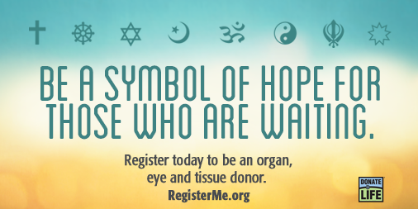

This package contains newsletter inserts, sample Inspirational sermons, Bible passages, hymns, and poems for a variety of faith communities.
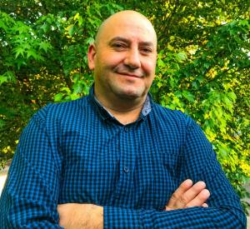JAIME FLORES
Jaime is a devoted husband, father, and brother whose faith is so big that he feels blessed that God thought of him when his brother, Ramon, needed a kidney transplant.
When Ramon got sick and his health was deteriorating, Jaime realized how difficult it was going to be for Ramon to find a kidney. This is mostly because not everyone around them knew a lot about organ transplants and donation.
Doctors gave the brothers hope by telling Jaime that he was a good candidate to donate his kidney to his brother and with that, he was going to be able to save his brother’s life.
Ramon’s life changed completely after receiving Jaime’s kidney in February 1998, and each aspect of his life got better. He now has three kids and is happy, living life to the fullest. They are both so thankful for the gift God gave them.
“God gave us this amazing life; we can help by saving lives.”

www.donatelifenw.org

- VIDEOS
Visit www.DonateLifeNW.org to find Power Points, videos and graphics designed for faith, community, and school-age children related to donation and the Donor Registry

- BULLETIN INSERTS
Donate Life Northwest participates in several National Observances; we invite you to join our public outreach efforts by adapting the inserts below for the following:

National Donate Life Month, April
National Donate Life Month features an entire month of local, regional and national activities to help encourage Americans to register as organ, eye and tissue donors and to celebrate those that have saved and healed lives through the gift of donation.

National Minority Donor Awareness Month, August
This nationwide observance honors the generosity of multicultural donors and their families, while also underscoring the critical need for people from diverse communities to register as donors. It is a time to promote healthful living and disease prevention to decrease the need for transplantation and encourage people of all ethnic and cultural groups to register as donors.

National Donor Sabbath, 2nd weekend before Thanksgiving
National Donor Sabbath is a time for people of all faith to honor those who have given the lifesaving and healing gift of organ, eye and tissue donation. Every year during this special time, Donate Life Northwest, local donation and transplant organizations work closely with communities of faith to bring the message of donation to congregations around the country.
Give the gift of life.
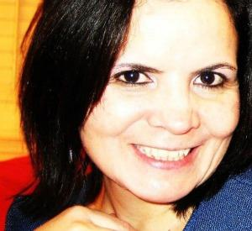Teresa Rambaud
Thanks to four cornea donors and their families, Teresa sees and lives life in bright, vivid color.
When Teresa was 20, she had become totally blind. Life was dark and difficult at times, and she would often fall and hurt herself. Teresa was incredibly grateful for the care and support of the teachers, classmates, and family.
At the ages of 22 and 24, Teresa received her first two cornea transplants from donors in El Paso, Texas. For the first time in almost four years, her world turned from dark and gray to bright, vivid color.
Teresa urges others, “Share your blessings! Become an organ, bone marrow, eye, and tissue donor. Also, support your loved one’s decision to help many patients in need: deciding to give someone life or sight after you are gone – it’s amazing – the most beautiful and selfless action of compassion!”

www.donatelifenw.org

Our congregation supports organ and tissue donation as the gift of life and the expression of highest humanitarian ideals. We ask that all members of congregation consider this gift in the name of Christ, who gave His life so that we might have life in its fullest.
Our congregation supports and encourages organ and tissue donation as the ultimate gift of one person to another. Take a moment to discuss organ and tissue donation with your family. Please consider making this great gift in God's name.
To think of others in our hours of grief and sorrow is truly compassionate and selfless. Please consider the gift of life— organ and tissue donation. Our congregation supports this gift in the spirit of love and generosity. Remember to discuss your feelings about organ and tissue donation with your family.
How do we respond to the blessings God has bestowed on us? How do we deal responsibly with the gifts God has given us? To think only of ourselves is to squander our lives. But to respond gratefully means we praise God with our lips and our actions. To respond gratefully is to realize that all of life is God's, and we are called to care for it and share it. With these thoughts, we ask you to consider giving so that others may live. Give the gift of life—organ and tissue donation.
Our congregation recognizes the life-giving benefits of organ and tissue donation and encourages its members to register as donors, whether online through Donate Life Northwest or at the DMV. By doing so, they attest to their commitment upon death to giving organs and tissues to those in need as part of their ministry to others in the name of Christ, who gave his life so that we might live.
Consider how simple acts may change the lives of others who have great need. The next time you visit the DMV, say yes to being an organ and tissue donor; that's a simple act. In saying yes, you are demonstrating a willingness to give life to others after you no longer live. Think of it for others in need.
Thousands of us are in need of vital organs and tissues. For many, the chance to live a full life won't come unless all of us consider organ and tissue donation. Discuss organ and tissue donation after worship with your family and friends. Help others find a chance to live a full life. Share your life, share your decision.

For many bright, young, talented people, the chance to live a full life rests with all of us, for some of them will die unless we consider making a great gift. Those in need of organs and tissues number in the thousands. An untimely death awaits those who do not receive organs and tissues that now are simply wasted in death. After worship, talk with your family and friends. Think about giving a full life to others when your own life ends. Consider a great gift; be an organ and tissue donor.
Every year thousands die because a virtually free gift is too seldom given. Those who die are bright, young, talented people with years of living ahead … except for organ failure. The gift of life—organs and tissues—is one that costs only the decision to give, yet that decision can literally mean life or death to someone in need. Organ failure could affect us all. All of us should consider giving organs and tissues after our lives have been lived.
After worship, discuss organ and tissue donation with family and friends. Let them know that you understand the need for organs and tissues among those who rely on transplantation to live. For us, the only cost is giving, for the gift is life. Share your life; share your decision.

SERMON IDEAS
Clergy have their own unique way of sermon preparation and delivery. With that understanding and appreciation, the following suggestions are given as ideas. The following Scripture references are available as starting points and ideas.
John 11:25: "I am the resurrection and the life." I Corinthians 15:35-58: The spiritual body these verses could be used to teach about the resurrection, emphasizing that in the resurrection the physical body is transformed into a spiritual body. Therefore, the gift of organs and tissues does not affect the ability of one to be resurrected.
Luke 6:31-38: Give to others and God will give to you This verse could be explored as to the command to give to others and various ways that we can give, including the giving of our bodies.
Romans 8:28-29: Seeking the good This verse could be used to show how, in the midst of tragic circumstances of sudden death, God is seeking with us to find good. Donation may be one sign of good in an otherwise senseless death.
John 3:16-17: God gave His Son God gave His son to us so that we might live in eternal life. Can we not give of our organs and tissues when we no longer have need of them so that others may live in this temporary world?
Luke 14:12-14: Giving without reward In this verse we are told to give to those who are in need without thought of reward from them. The need for organ and tissue donation is great.
Genesis 2:26-31: Responsible power In the moment of our creation we were given power over all things. Responsible use of this power would include using our own bodies to give life.

BIBLICAL PRINCIPLES SUPPORTING DONATION
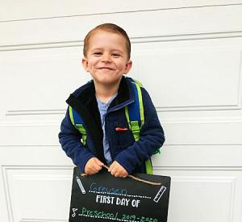Greysen Galbasini
Greysen was suffering from a genetic liver and lung disease known as Alpha1 Antitrypsin Deficiency (A1ATD).
His liver was failing, and fluids were building up in his little body. Before long, he was moved into the ICU and placed on 1A status for liver transplant. On August 23, 2016, the transplant team woke the Galbasinis to let them know there was a potential match from a deceased donor.
His mother, Stefanie says, “Greysen came out looking like a whole new kid. His skin was a different color, his swelling was down. He was perfect. He was beautiful.”
“Please sign up! If it wasn’t for a donor, my son wouldn’t be here today…. When you donate life, you are someone’s hero. We can’t change when or how we will pass, but saving someone’s life is within our control.”
3-year-old Greysen Galbasini is a happy, healthy preschooler thanks to a generous liver donor.
www.donatelifenw.org

Organ and tissue donation is not specifically mentioned in the Bible. However, the timeless content of the scriptures speaks to donation in principle. The following Scriptures can guide our thinking and actions on organ donation:

Genesis 2:20-30 The first transplant: a rib taken from Adam to create Eve.
Ezekiel 37 The Valley of Dry Bones, "These bones shall live."
Matthew 5:7 Blessed are the merciful.
Matthew 7:7 Ask ... seek ... knock.
Matthew 7:12 "Whatsoever ye would that men should do unto you, do ye even so to them."
Matthew 10:8 "Heal the sick, ... freely ye have received, freely give."
Leviticus 1:7 "Thou shalt love thy neighbor as thyself."
Mark 9:47 We can enter heaven without having every part of our bodies present.
Luke 6:37-38 Give and it shall be given unto you.
John 3:16-17 God so loved the world that he gave ...
John 10:10 Give life that others may live more abundantly. John 15:12-13 Greater love has no man ... I
John 4:11 "If God so loved us, we ought also to love one another."
Revelation 21:4-5 In eternity we will not need our earthly bodies: "Former things will pass away, all things will be made new."

Contributed by Mid-America Transplant Services

SUGGESTED HYMNS
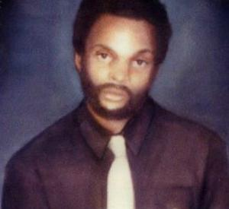Bobby Olive,Sr.
Bobby's sudden, devastating death left a hole in his family, yet bonded them together with a new family and brought them all healing through his heart donation.
Bobby was “at the wrong place at the wrong time” when he was tragically shot. In the early morning hours of December 4, 1985, doctors at Legacy Emanuel told Martha Van Arsdale, that her son, Bobby, would not survive. They also told her that if she agreed to donate his organs, other lives would be saved.
Martha, a devout Seventh Day Adventist, took time to pray about it and then told doctors “yes.” She was sure that her son would have wanted it that way. In fact, Bobby would become the very first heart donor in the state of Oregon.
Decades later, Bobby continues to save lives by inspiring others to say “yes” to organ, eye, and tissue donation.

www.donatelifenw.org

The following list of hymns is a start in your efforts to locate appropriate hymns from your own religious tradition that bring the message of hope and giving that organ and tissue donation and transplantation provide.
- "I'll Praise My Maker While I've Breath"
- "Amazing Grace"
- "Bless Me Now"
- "Come, Sinners, To the Gospel Feast"
- "Jesus, Lover of My Soul"
- "Have Thine Own Way, Lord"

National Donor Sabbath —Sample donor recognition program

Prayer Here is a sample prayer that clergy members may like to incorporate in a service on the donor recognition program. It can also be included as a written prayer in a weekly bulletin.

O God,
We thank Thee for the gift of life. May we always cherish this gift and protect it in the cradle of responsibility.
May we understand that our bodies are the houses of Thy infinite spirit.
The mortal house is a temporary abode, but within is the brilliant light of eternity.
Every chamber is a repository of vitality. Each is a place of life.
Together, they form a temple of God.
Amen.

Benediction

Here is a sample benediction a clergy member may like to include at the end of a donor recognition program.
As we go from this House of Worship, may we take with us the words and the spirit that our faith offers us.
Here, we learn of and sing praises for the gift of life. We declare that while we live, our bodily form is the vessel that receives God's light. May we be worthy bearers of that light in bodies which are strong and healthy.
From our eyes, may the light shine brightly so that in the darkness we may see the needs of others. Through our ears, may we hear beyond the noise of self-interest to the calls for help from those in need.
May our hearts beat with compassion and our arms be strong in reaching out to lift up those who stumble.
And after life has gone from us, may we still remain the messengers of Thy light. May the sparks housed within us, because of our offering of love, become the flame of life for others.
Amen.
Contributed by Tennessee Donor Service

INSPIRATIONAL WRITING

To Remember Me

The day will come when my body will lie upon a white sheet neatly tucked under four corners of a mattress located in a hospital busily occupied with the living and the dying. At a certain moment a doctor will determine that my brain has ceased to function, and my life has stopped.
When that happens, do not attempt to instill artificial life into my body by the use of a machine. And don't call this my deathbed. Let it be called the Bed of Life, and let my body be taken from it to help others lead fuller lives.
Give my sight to the man who has never seen a sunrise, a baby's face or love in the eyes of a woman.
Give my heart to a person whose own heart has caused nothing but endless days of pain.
Give my blood to the teenager who was pulled from the wreckage of his car, so that he might live to see his grandchildren play.
Give my kidneys to one who depends on a machine to exist from week to week.
Take my bones, every muscle, every fiber and nerve in my body and find a way to make a crippled child walk.
Explore every corner of my brain. Take my cells, if necessary, and let them grow so that, someday, a speechless body will shout at the crack of a bat and a deaf girl will hear the sound of rain against her window.
Burn what is left of me and scatter the ashes to the winds to help the flowers grow.
If you must bury something, let it be my faults, my weaknesses and all prejudice against my fellow man.
Give my sins to the devil.
Give my soul to God.
If, by chance, you wish to remember me, do it with a kind deed or word to someone who needs you.
If you do all I have asked, I will live forever.

Robert N. Test

